

PROPOSAL DOCUMENT

Vulnerability Assessment &
Penetration Testing (VAPT) Report

Ipin Group Technologies

29 August 2023
© Sautech (Pty) Ltd. http://www.sautech.net

TABLE OF CONTENTS

1 Executive summary 3
2 scope of testing 3
3 Methodologies used 3
3.1 Nessus 3
3.2 Greenbone Enterprise 3
Stay One Step Ahead of Attackers 4
3.3 OWASP 4
4 virtual servers 5
4.1 Application Server 5
5 Reporting Conclusion 6
6 Auditors 6

Executive summary

The purpose of this assessment was to point out security loopholes, business logic errors, and missing best security practices. The tests were carried out assuming the identity of an attacker or a malicious user but, no harm was made to the functionality or working of the application / network. A full scan was also performed on the infrastructure to demonstrate a known attack, i.e. someone on the internal network or same public subnetted infrastructure. The scans and brute force were performed over 5 (five) business days, as full and slow comprehensive audits were performed. These types of scans also look at unknown connectivity options, including packet SYN requests.

The overall results will be published below, High-level, Sautech is comfortable and happy with the results. Some recommendations however, is offered and also mentioned throughout this document.

scope of testing

Security assessments include testing for security loopholes in the scope defined below. Apart from the following, no other information was provided. Nothing was assumed at the start of the security assessment. The following scope of servers were covered under the security audit:

- Server hosted at Afrihost
- 1 (One) x Hosted Virtual Server namely:
  - Ipin Application = 41.76.214.242 pentest.ams360.co.za

Methodologies used

Sautech performed various audit techniques that includes the following:

Nessus

Nessus is a remote security scanning tool, which scans a computer and raises an alert if it discovers any vulnerabilities that malicious hackers could use to gain access to any computer you have connected to a network. It does this by running over 1200 checks on a given computer, testing to see if any of these attacks could be used to break into the computer or otherwise harm it.

Greenbone Enterprise
Greenbone is the world’s most widely used vulnerability management provider.

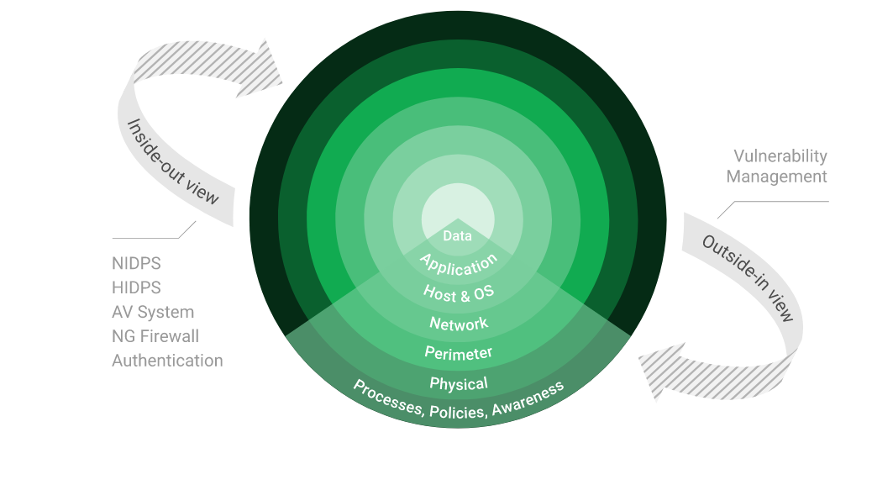

Stay One Step Ahead of Attackers
IT security is a process – Open Source vulnerability management provides the foundation. Once you know where the chinks are in your armor, you can do something about them.

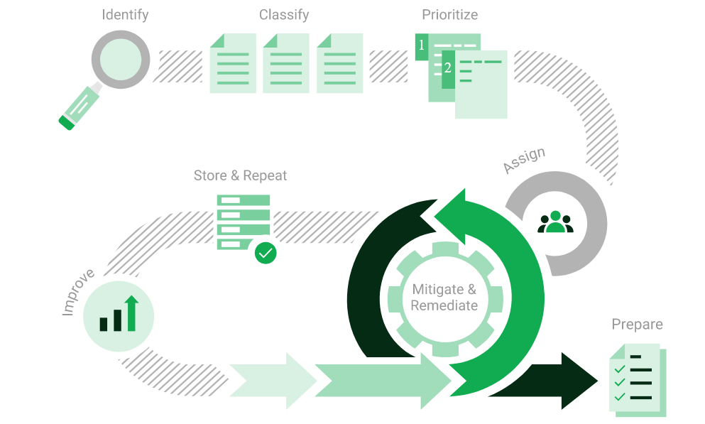

The process – from recognition to remedy and monitoring – represents a continuous cycle. You’ll always be one step ahead of attackers.

OWASP

The Open Web Application Security Project (OWASP) is an online community that produces freely-available articles, methodologies, documentation, tools, and technologies in the field of web application security. The Open Web Application Security Project (OWASP) provides free and open resources. It is led by a non-profit called The OWASP Foundation. The OWASP Top 10 - 2021 is the published result of recent research based on comprehensive data compiled from over 40 partner organizations.

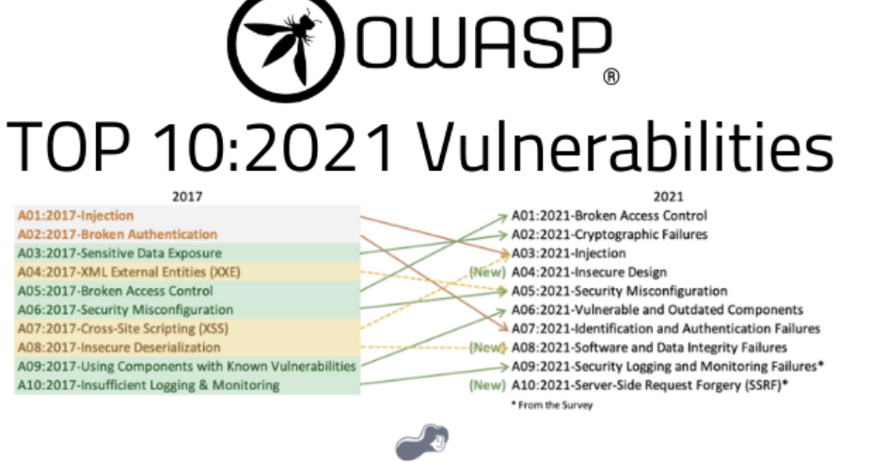

virtual server

Application Server

We have performed the following additional scans / attacks on the application server namely:
- Vulnerability Assessment

Vulnerability Assessment
Multiple technologies were used to perform a vulnerability assessment, below is the summarised version of the relevant results:

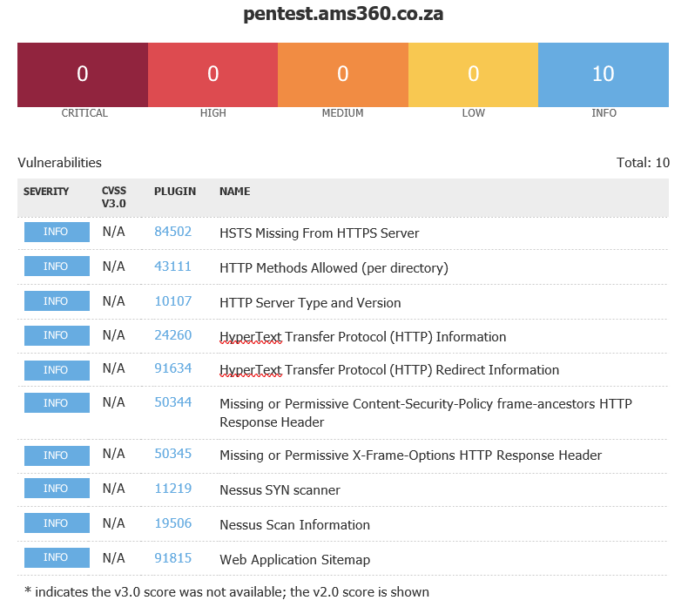

These are all in separate documents for ease of reference to this report.

Reporting Conclusion

Based on the OWASP reports it is best to attach these separate to the reporting document. These reports can then be shared with the relevant contractors and/or support personnel to implement the changes and updates.

The HTTPS updates as these are open to the public, low and medium risk, should be tested and implemented as soon as possible.

From a Hosted Infrastructure point of view, we are happy with the results.

Three addendum reports are attached to this report and should be read as one document.

With the following test performed:

- Network scanning
- External HTTP and Port exploits
- Vulnerability assessment on CVE
- Penetration testing on open Ports i.e. HTTPS

Sautech concludes that best practise methodologies and technologies are used inside and supporting the hosted Ipin Infrastructure.

Auditors

These audits were concluded over a period of 5 (five) days.
We hereby confirm that the above information is true and correct:

29th August 2023 – Krugersdorp, South Africa

_________________________ _________________________
Riaan van Jaarsveld Lukas Janse van Rensburg
Security Expert – CCSA Security Engineer

